



How to Use Harbor in DeviceOn

Rafael Yu

2022.5.9

To use on-premise Docker Registry service in DeviceOn, you can run a Harbor server.

Harbor is an open source registry server, you can find more detail in official website: (<https://goharbor.io/>)

There are two ways to use Harbor. One is install a Harbor server on your own machine. Another one is using a demo environment, which is hosted by Harbor officially.

Here will briefly introduce how to sign up a testing account and how to use it in DeviceOn.

**Sign up a Harbor testing account in demo environment**

(The testing account will vanish in 24 hours, and the data will be cleared or be changed w/o notifying)

1. Open Harbor live demo website: [https:// demo.goharbor.io /account/sign-in](https://demo.goharbor.io/account/sign-in)  
   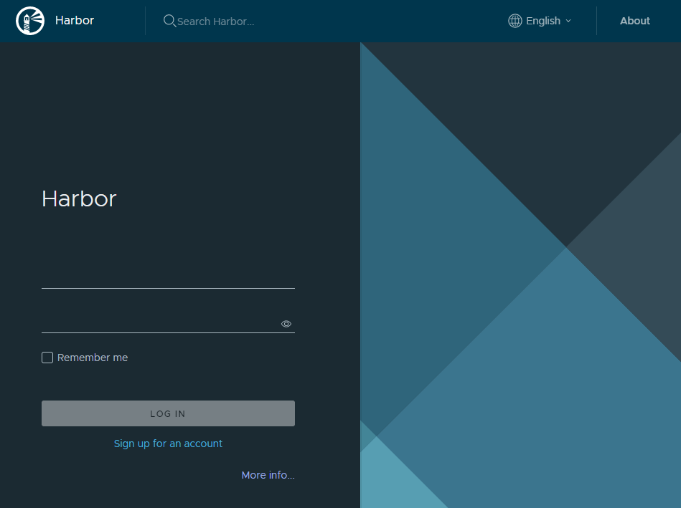
2. Click [Sign up for an account]. Fill required columns then click [SIGN UP].  
   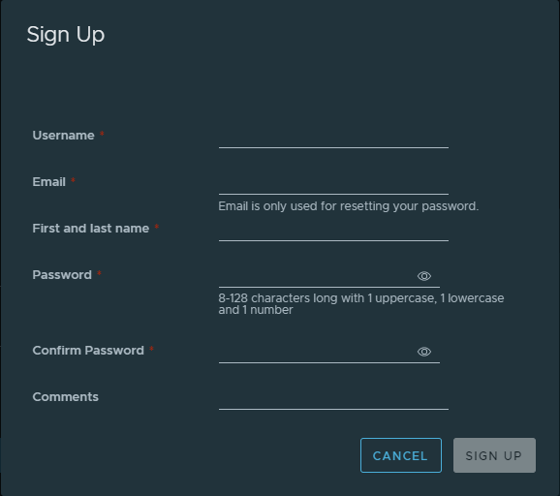
3. Sign in with the account you created.   
   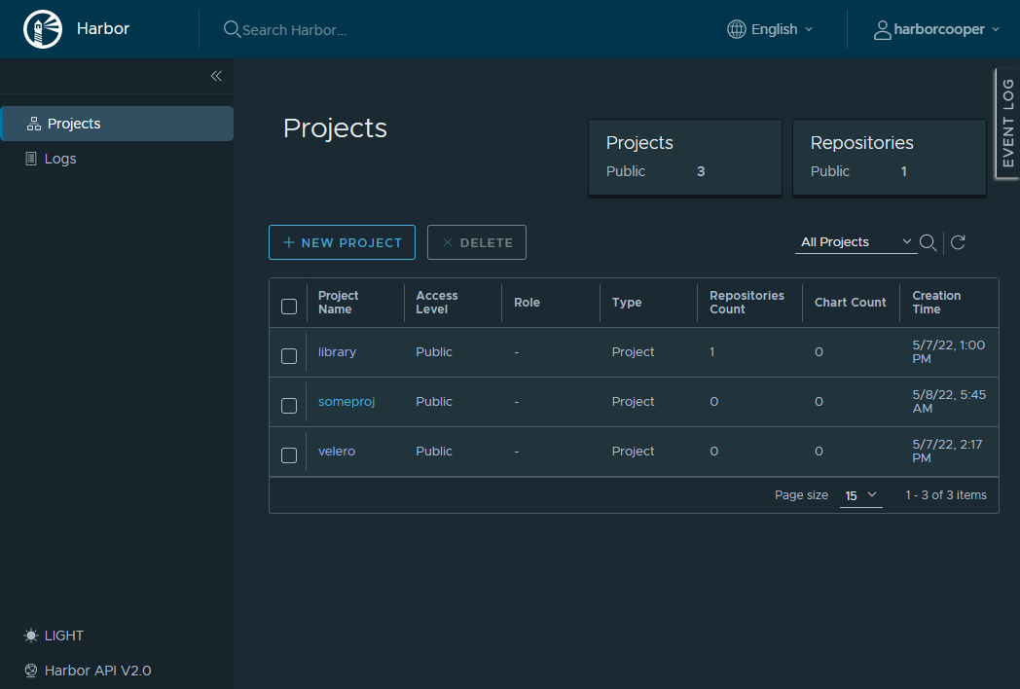
4. Click [NEW PROJECT] to create a namespace of registry. Enter a unique name, here we use “my-harbor-2” as sample.  
   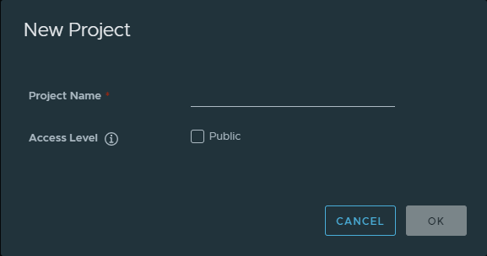  
   Click [OK], the new project list below  
   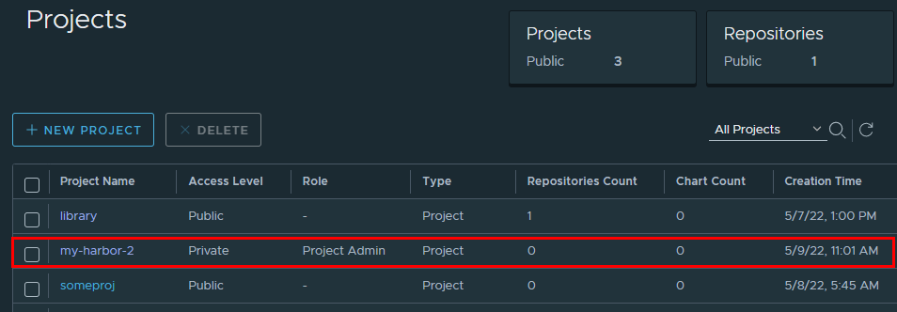

For now, our Harbor registry is ready for DeviceOn.

DeviceOn need Registry connection info are: **Registry URL, user, token**.

|  |  |
| --- | --- |
| Registry URL | **{Harbor URL}**/**{Project Name}** |
| User | {Harbor User Name} |
| Token | {Harbor User Password} |

Below is our sample

|  |  |
| --- | --- |
| Registry URL | **demo.goharbor.io**/my-harbor-2 |
| User | harborrrrr |
| Token | Abcd123456 |

**Set up Harbor registry in DeviceOn**

1. Open [Registries] in Container Management  
   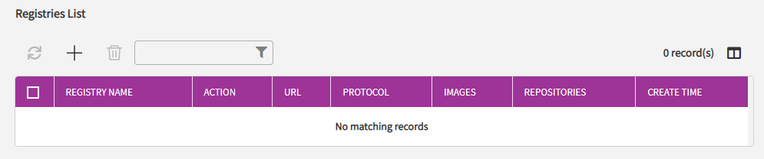
2. Click [＋] to add new registry connection info  
   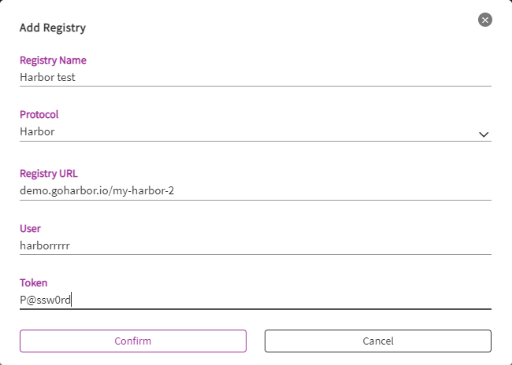  
   Click [Confirm] to finish. A new row will show in list.  
   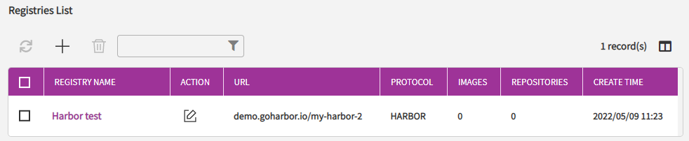
3. Click the registry name to view detail of registry we just created.  
   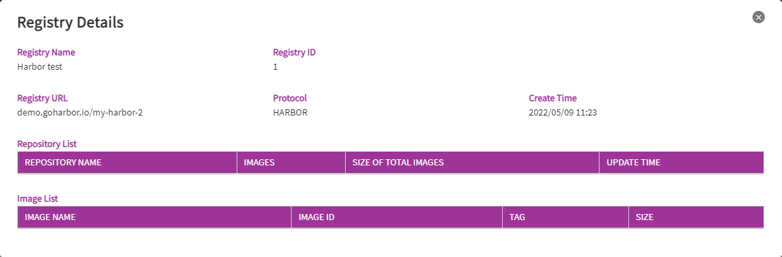

After creating a registry connection info in DeviceOn, we can push a container image to Harbor to verify Harbor and DeviceOn.

**Push image to Harbor Registry, and synchronize to DeviceOn**

1. Docker login Harbor registry.

$ sudo docker login demo.goharbor.io

Username: harborrrrr

Password:

Succeeded

1. Tag an image in format: **{Harbor URL}**/**{Project Name}**/**{Image Name}**:**{Tag}**

$ sudo docker image tag hello-world demo.goharbor.io/my-harbor-2/test-image:latest

1. Push the image.

$ sudo docker image push demo.goharbor.io/my-harbor-2/test-image:latest

The push refers to repository [demo.goharbor.io/my-harbor-2/test-image]

e07ee1baac5f: Pushed

latest: digest: sha256:f54a58bc1aac5ea1a25d796ae155dc228b3f0e11d046ae276b39c4bf2f13d8c4 size: 525

1. Synchronize manually in DeviceOn.   
   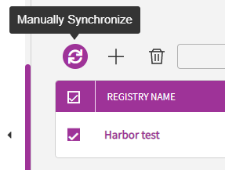
2. Check the image is in image list.  
   